Lesson Plan
Theme: Toy Run
Grade : 8th
Date : 12 .09.12
Objectives : SWBA to watch the video, listen and talk about the charity.
Materials : books, CD, cards

Procedure
I.Warm up.
Review the material give, take, sell, buy, listen
Check the home work
Read the sentences
II.Presentation
Before you watch.
Do you know the name of any charity?
What do they do?
Have you ever given anything to charity?
With a friend, make a list of different things you can do for charity.

III.Practice
Wile watching
In Markham Park
Listen to Lauren. Complete the sentences using the words :
Buying , listening , great music, waiting around, the motorbikes .
Hi folks! We are here at Markham Park in South Florida. We’re actually waiting for … to arrive. There are lots of people … , chatting, …. Food. They’re also … to some
What are they wearing?
a)Match the words with pictures 1-8
Boot, pjams, gloves, helmet, leather trousers, scarf, sunglasses

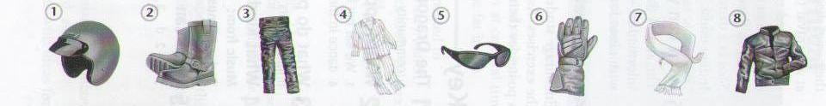
IV. Production How long have you been doing this?
Listen to the man and complete the text with correct numbers. Choose : 3,8, 8th, 10 or 18
This is my … toy run. They’ve been doing it … years.I’ve been living in South Florida for … years and I started doing it … years ago and it’s a great event. The Toy Run is about the kids, seeing the smile faces- I have … children.
V.Who says it?
- Match people 1-3 with sentences a-f

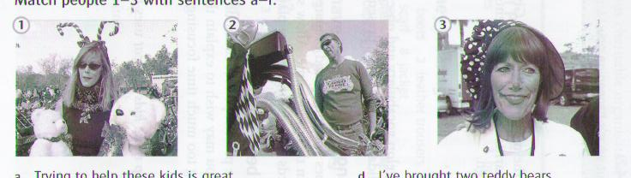

- Trying to help these kids is great.
- These children would love a gift for Christmas.
- Thank you to everyone here who supports us!
- I’ve brought two teddy bears.
- I have three children.
f) I’m here to have fun.
VI .After watching. Answer to questions
Where is Toy Run?
What can you give for charity?
How do you help for people in need
VII. Hometask.
Write an article a about a charity

